Name | Ndongla Roy Longpi
Department | Computer Networking and Security
Task | Blind Time SQL injection

BLIND/TIME BASED SQL INJECTION AND DATABASE EXTRACTION
Blind SQL injection: this is a situation where an app or website doesn’t show anything, that is no error, no extra data, no visible difference in the page even though your SQL injection is been executed on the back end.
To over come this effect there are two main indirect ways to obtain a yes or no answer from the data base which I am going to be implementing in my blind injection and database extraction which are.
Boolean-based blind: Here, the database is been asked a true or false question and the page react differently bases on it response. If true it loads normally if false it doesn’t.
Time-base blind: in this case, when you ask a true or false question, instead of relying on it visible difference you give it a sleep time. Which if response is true it comes after the number of seconds later if false response is gotten instantly.
I carried out my blind SQL injection and database extraction in the following steps below:
Which will be carried out mainly on kali linux, the vulnerable app(DVWA) and buspsuite as followed.
- Setting up my SQL injection lab.
Setting up my sql injection lab involves running commands on kali Linux for starting up Apache, MariaDB and giving me a link for accessing my DVWA through a local browser.

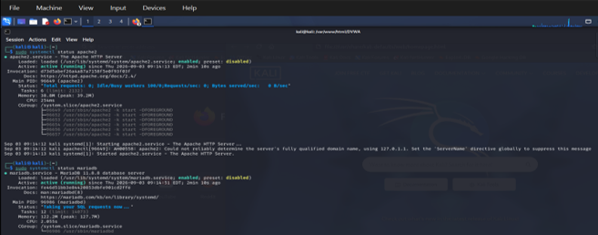
- Adjusting security level and testing normal blind SQL injection on DVWA.
After accessing the DVWA via a local host, I moved on to adjusting it security level from impossible to low, in order for DVWA to allow me perform any form of attack on it.
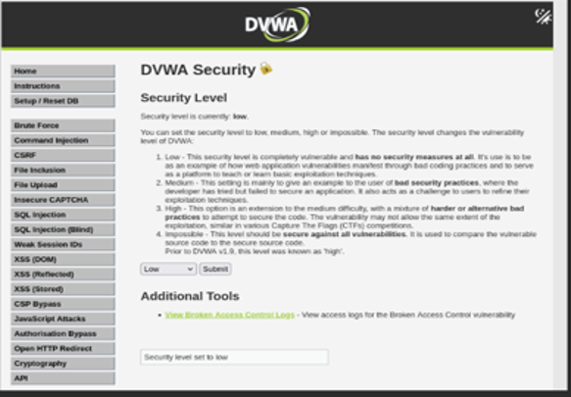

I later on ran a normal user id on blind SQL injection which provided a baseline response which will be use later on to check the response produced by SQL injection payload.

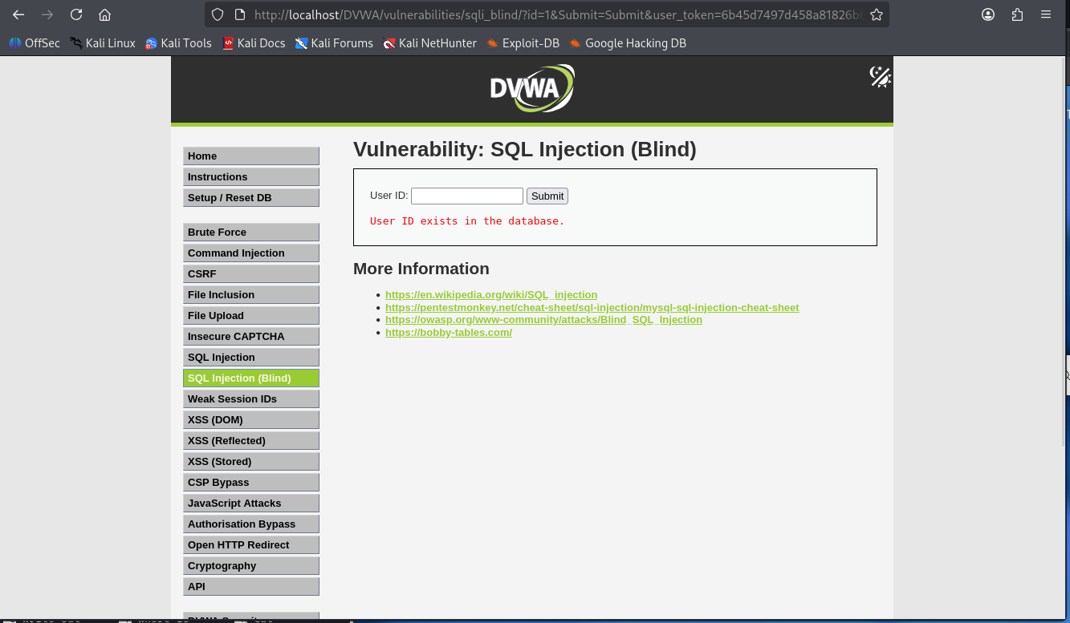

- Implementing normal blind SQL injection request on DVWA
under the Boolean based blind sql injection, I passed two SQL injection condition for both true and false which gave me a response indicating both conditions where accepted. Since the response were different I later on compare the response to determine if the injected conditions were true of false.

For Boolean true.
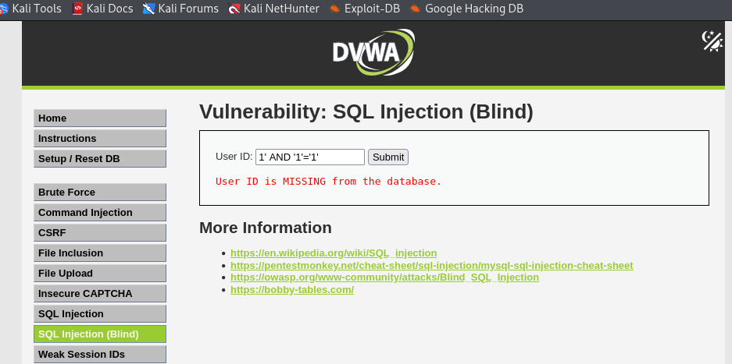

for Boolean false.
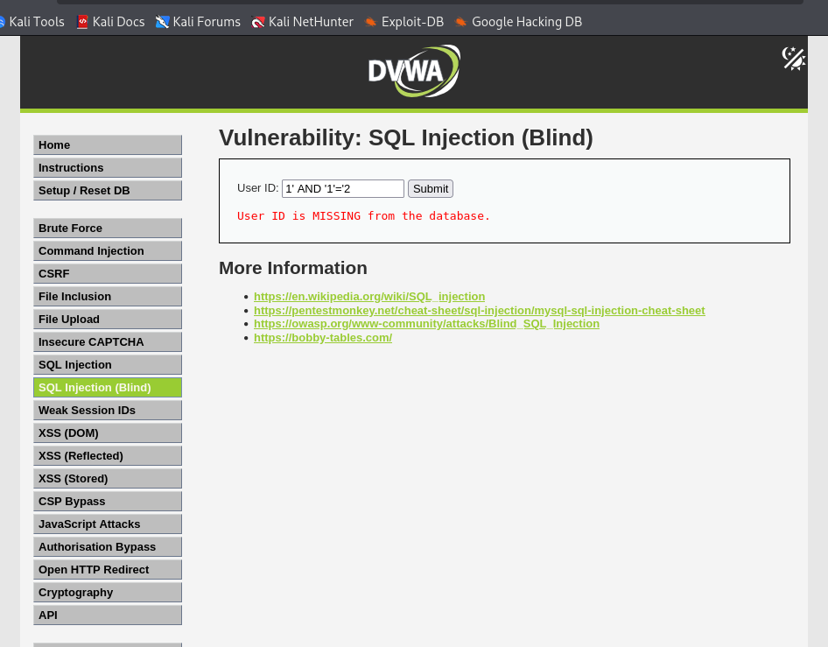
Under time-base blind I passed an SQL injection condition with a sleep time of five second, which gave a response, indicating the condition has been accepted. For that of the SQL injection test above command response was given instantly while for this one there was a delay time indicating the response is true.

For time base true.
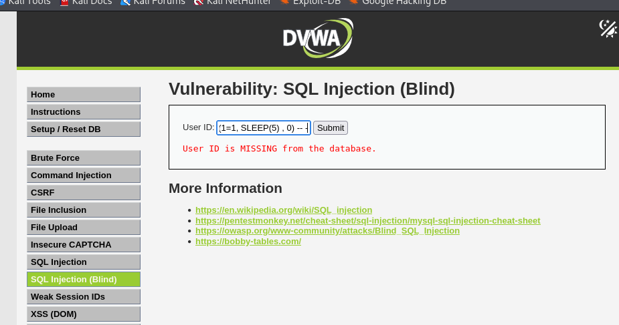
- Intercepting request using Burp Suite.
With the help of Burp Suite which was obtain by entering the command “burpsuite” on Linux I was able to examine the SQL injection page via proxy between Firefox and DVWA.
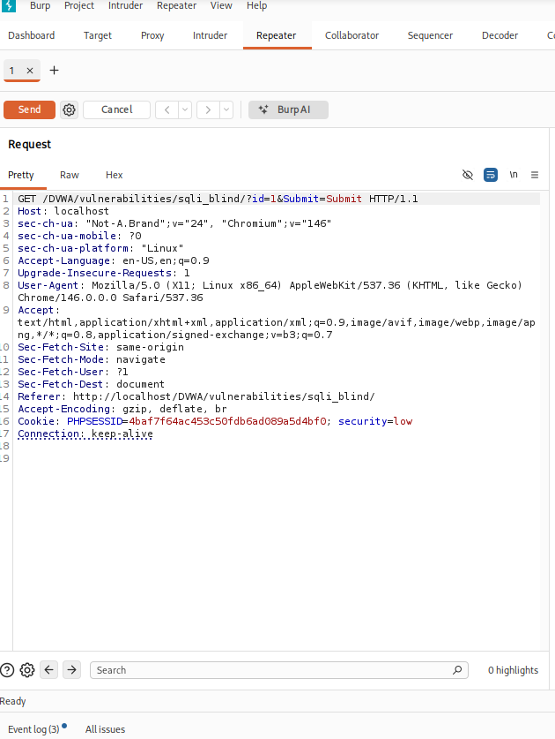
Burp suite request and response illustration of DVWA.
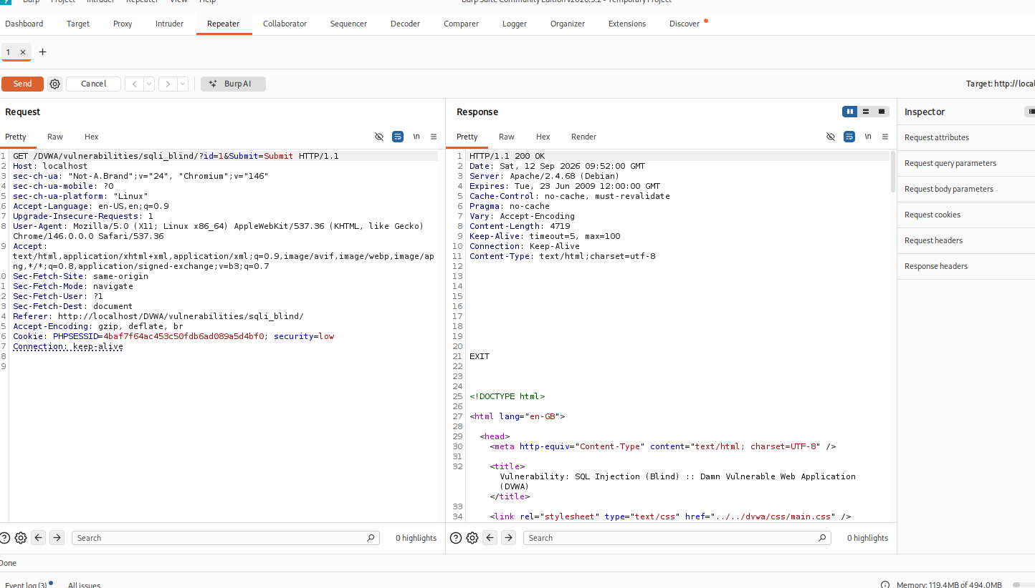

- Confirming vulnerability with sqlmap.
The next thing I did after identifying injection point, was to identify the vulnerable parameters and confirmed the presence of blind SQL injection. This was done by entering a series of commands on Linux.
Command entered.
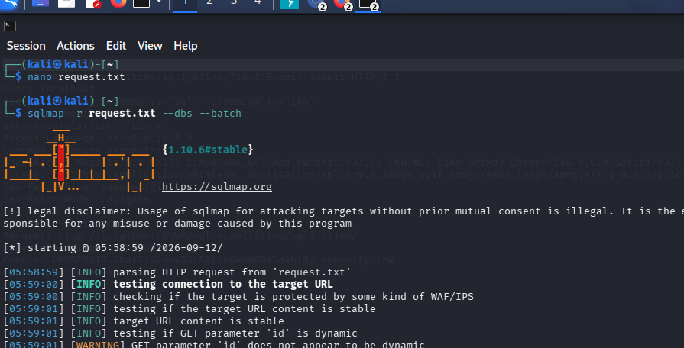
Response indicating the presence of vulnerable parameters and blind SQL injection

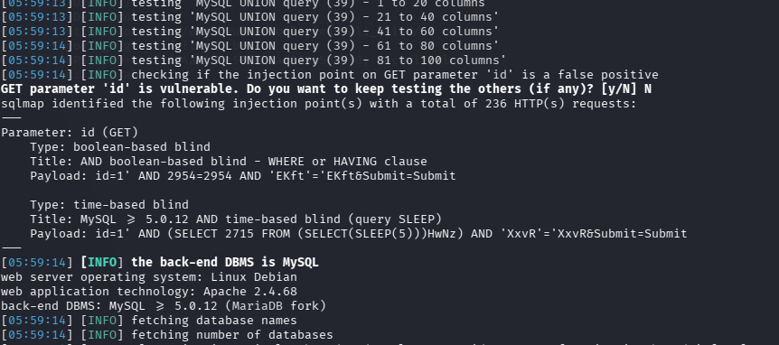

- Enumeration
After confirming vulnerability, with the help of SQL I was capable to enumerate the available database, tables and column on Linux.
Firstly I enumerate the database which showed that the database is accessible through the vulnerable application.

Database enumeration and output.
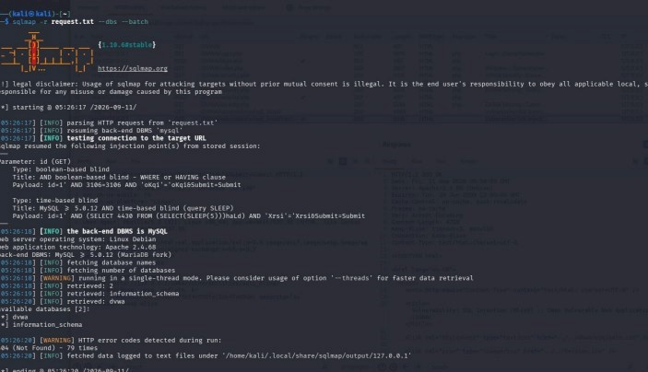

Using relevant DVWA database I enumerated the table.
Command and output showing the table.
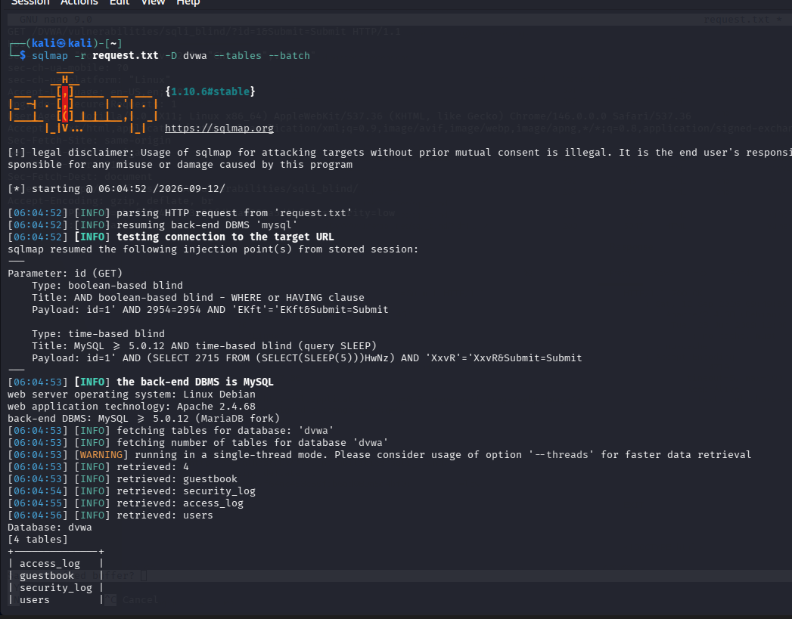

Lastly, I enumerated that of the column from the table
Column command
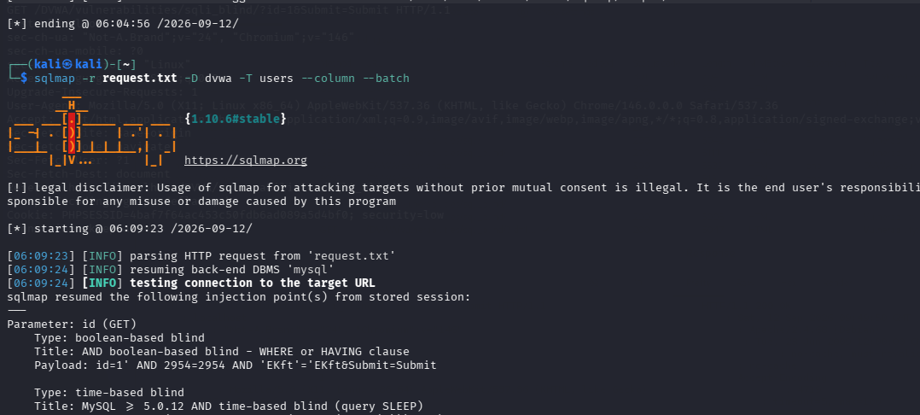

Output showing the columns
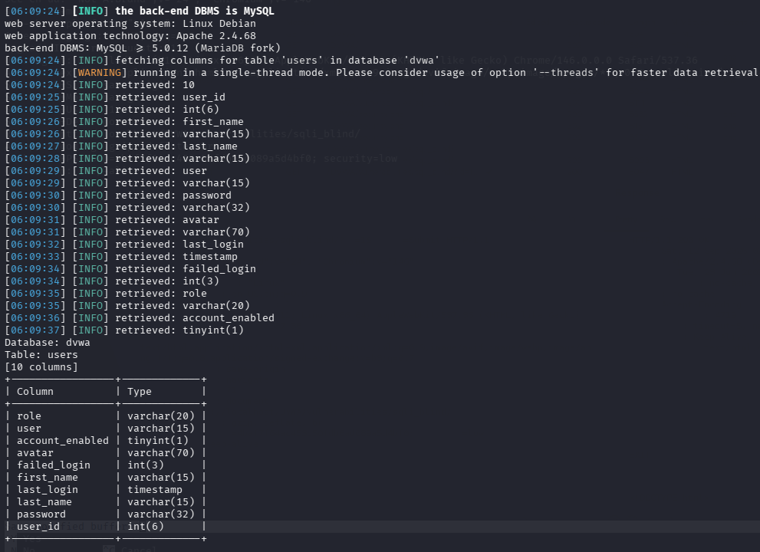

- Extraction of database information.
Further more, in order to clearly show how successful SQL injection can potentially expose sensitive information stored in the data base, I had to extract data from the laboratory database which includes users-related information and password hashes.

Extracted database
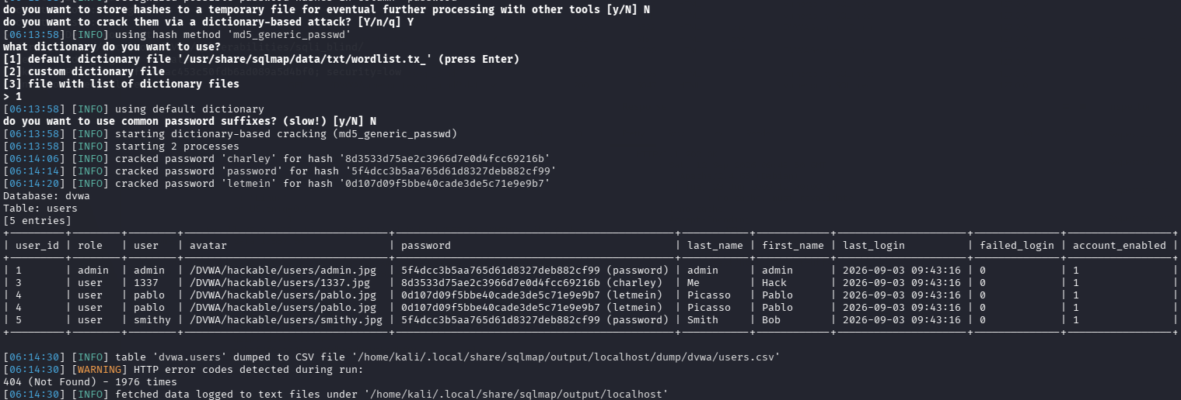
Password hash
For password hashing I used a hash identification tool to determine their hashing algorithm based on their structures.
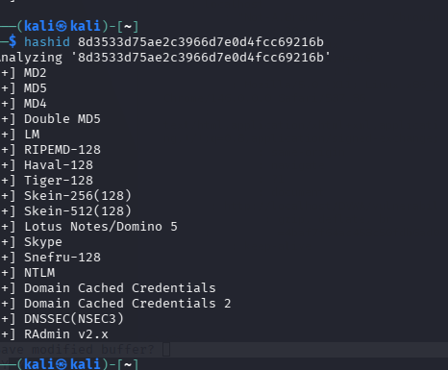

Conclusion: after I successfully implemented all the steps above, my blind time/Boolean base SQL injection and database extraction was finally complited.

